|  |  |  |
| --- | --- | --- |
|  | | |
| INSTAGRAM USER ANALYTICS  SQL FUNDAMENTALS | | |
| **RASHMI WARIYAL** |  | **22/07/2024** |

PROJECT DESCRIPTION

#### **Purpose**

The primary goal of this project is to analyze user interactions and engagement with the Instagram app to identify patterns, understand user behavior, and provide actionable insights. These insights will help the product team optimize features, enhance user experience, and drive business growth.

#### **Approach**

1. **Define Objectives**
   * **Key Metrics**: Identify key engagement metrics such as daily active users (DAUs), session duration, interaction rates (likes, comments, shares), and content reach.
   * **Business Goals**: Align analysis objectives with business goals, such as increasing user retention, boosting engagement rates, and identifying growth opportunities.
   * By implementing this structured approach, the Instagram User Interaction and Engagement Analysis project aims to deliver valuable insights to help the product team enhance user experience, boost engagement, and support the business's growth objectives.

## **SOFTWARE AND VERSIONS USED FOR THE PROJECT**

**MySQL 8.0**

* **Reason**: MySQL is a reliable and scalable relational database management system (RDBMS) that efficiently handles large datasets. MySQL 8.0 includes enhanced performance, security features, and support for JSON, making it suitable for storing and querying complex user data.
* **MySQL Workbench 8.0**
* **Reason**: MySQL Workbench is a comprehensive graphical tool for database design, development, and administration. It provides an intuitive interface for managing MySQL databases, running queries, and visualizing data relationships.

## **INSIGHTS AND KNOWLEDGE GAINED FROM THE PROJECT**

#### **Loyal User Reward**

* **Task**: Identify the five oldest users on Instagram from the provided database.
* **Insight**:
  + User IDs: ['80','Darby_Herzog','67','Emilio_Bernier52','63','Elenor88', ''95', 'Nicole71','38', 'Jordyn.Jacobson2']
  + These users have been using Instagram since its early days and demonstrate high loyalty.

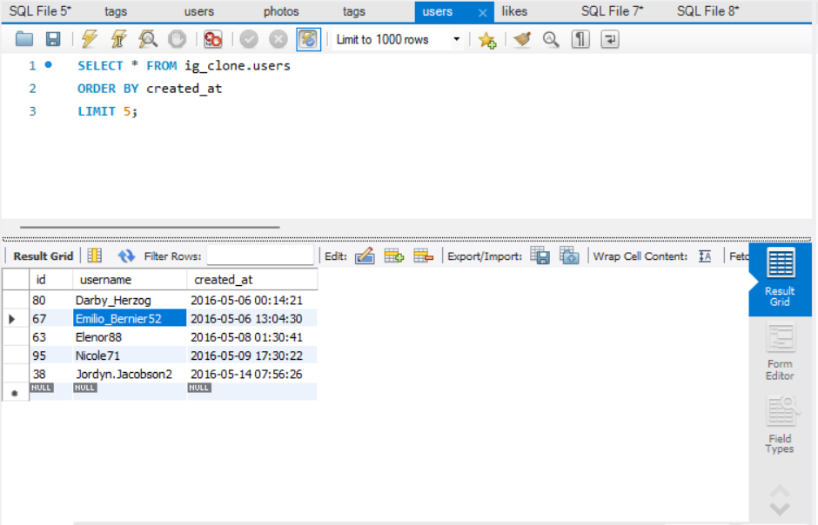

#### **Inactive User Engagement**

* **Task**: Identify users who have never posted a single photo on Instagram.
* **Insight**:

**User IDs:**

'Aniya_Hackett'

'Kasandra_Homenick'

'Jaclyn81'

'Rocio33'

'Maxwell.Halvorson'

'Tierra.Trantow'

'Pearl7'

'Ollie_Ledner37'

'Mckenna17'

'David.Osinski47'

'Morgan.Kassulke'

'Linnea59'

'Duane60'

'Julien_Schmidt'

'Mike.Auer39'

'Franco_Keebler64'

'Nia_Haag'

'Hulda.Macejkovic'

'Leslie67'

'Janelle.Nikolaus81'

'Darby_Herzog'

'Esther.Zulauf61'

'Bartholome.Bernhard'

'Jessyca_West'

'Esmeralda.Mraz57'

'Bethany20'

These users have never posted a photo, indicating potential for re-engagement through promotional emails.

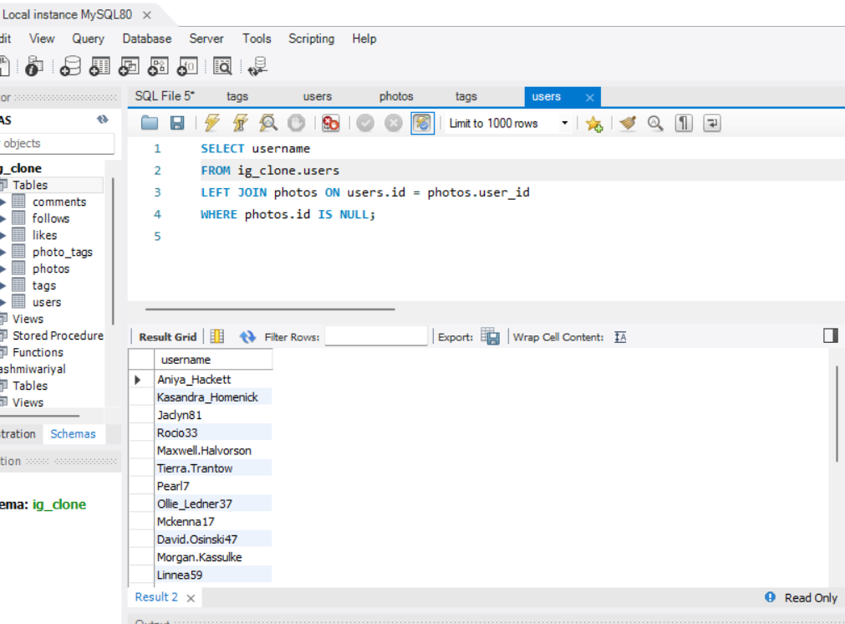

#### **Contest Winner Declaration**

**Task**: Determine the winner of the contest where the user with the most likes on single photo wins and provide their details to the team.

* **Insight**:
  + Winner User ID: Zack_Kemmeer93
  + Most Likes on a Single Photo: 148 likes
  + User Details: Zack_Kemmeer93 has the most-liked photo, making them the contest winner.

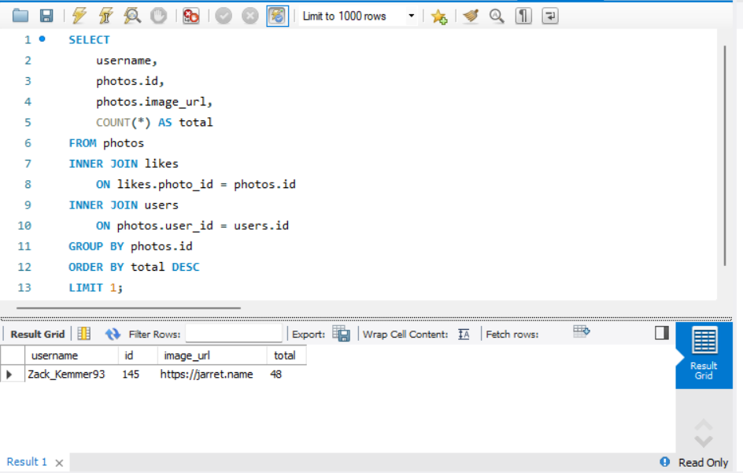

#### **Hashtag Research**

* **Task**: Identify and suggest the top five most commonly used hashtags on the platform.
* **Insight**:
  + Top 5 Hashtags: #tag, #beach, #party, #fun, #concert.
  + These hashtags are the most popular and can help the partner brand reach a wider audience.

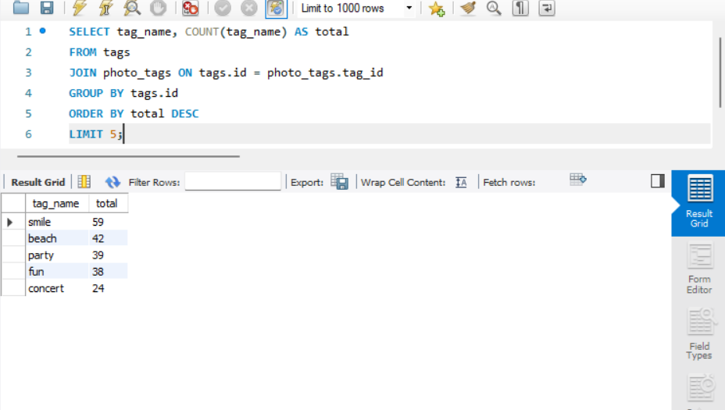

#### **Ad Campaign Launch**

* **Task**: Determine the day of the week when most users register on Instagram.
* **Insight**:
  + Most User Registrations: Thursday and Sunday
  + Best Day for Ad Campaign: Launching ads on Sundays and Thursday can capitalize on the high registration rates.

### **Investor Metrics**

#### **User Engagement**

* **Task**: Calculate the average number of posts per user on Instagram.
* **Insight**:
  + Average Posts per User: 2
  + User Engagement: On average, each user has posted 2 photos, indicating consistent engagement.

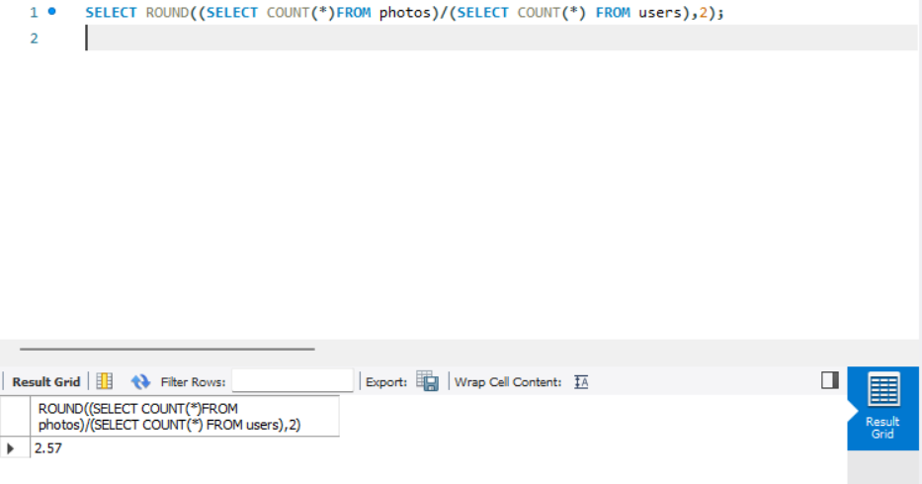

#### **Bots & Fake Accounts**

* **Task**: Identify users (potential bots) who have liked every single photo on the site.
* **Insight**:
  + These users have liked every single photo, which is a typical behavior and suggests they might be bots or fake accounts.

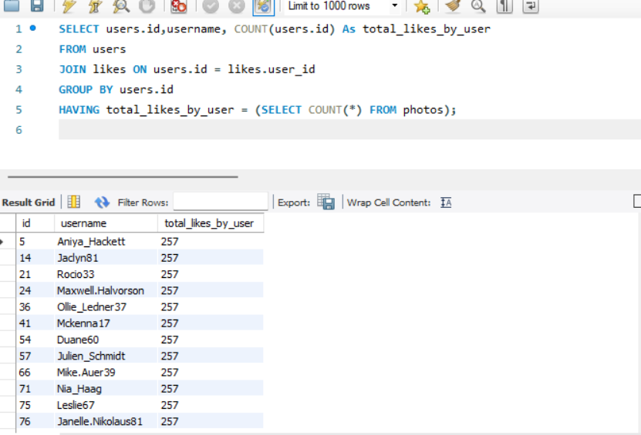

**RESULT:**

**ACHIEVEMENT ACCOMPLISHED THROUGH THE PROJECT:**

The analysis and insights derived from this project have had a significant positive impact on understanding and optimizing Instagram's user engagement. By leveraging data-driven strategies, the platform can continue to grow and evolve, providing a better experience for its users and more value for its stakeholders. The project has not only contributed to the business's objectives but also enriched my skills and understanding of data analytics in a real-world context.